Module 3 Assessment Solution:
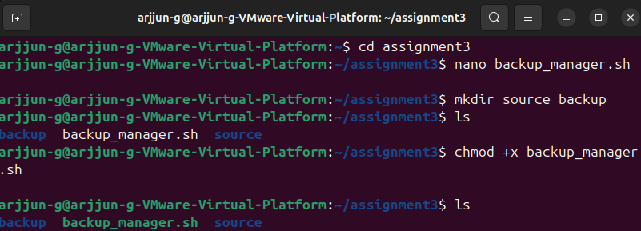
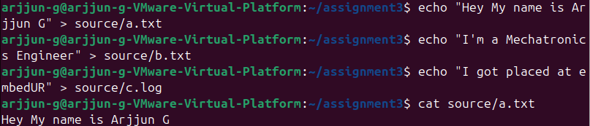
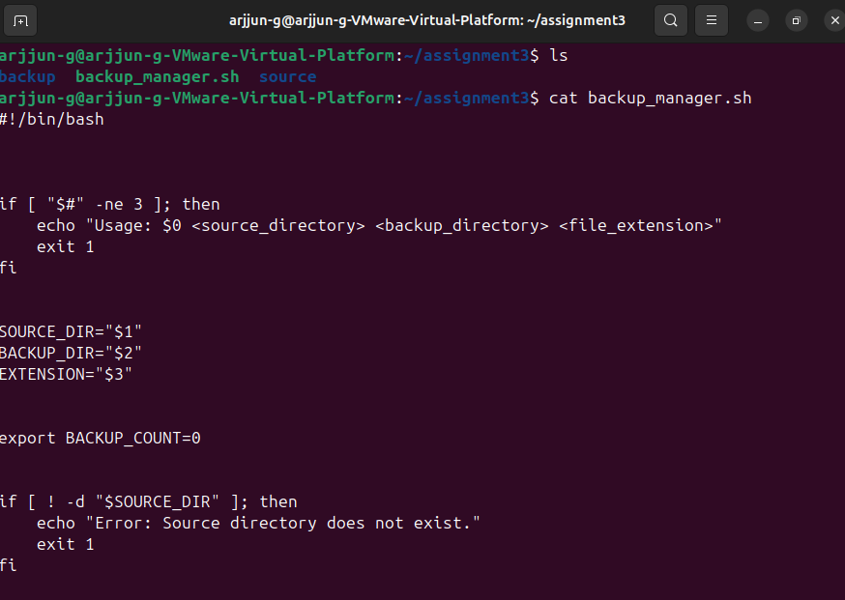

#!/bin/bash
if [ "$#" -ne 3 ]; then
echo "Usage: $0 <source_directory> <backup_directory> <file_extension>"
exit 1
fi
SOURCE_DIR="$1"
BACKUP_DIR="$2"
EXTENSION="$3"
export BACKUP_COUNT=0
if [ ! -d "$SOURCE_DIR" ]; then
echo "Error: Source directory does not exist."
exit 1
fi
if [ ! -d "$BACKUP_DIR" ]; then
mkdir -p "$BACKUP_DIR"
if [ $? -ne 0 ]; then
echo "Error: Failed to create backup directory."
exit 1
fi
fi
shopt -s nullglob
files=("$SOURCE_DIR"/*"$EXTENSION")
if [ ${#files[@]} -eq 0 ]; then
echo "No files with extension $EXTENSION found in source directory."
exit 1
fi
echo "Files to be backed up:"
TOTAL_SIZE=0
for file in "${files[@]}"; do
size=$(stat -c %s "$file")
echo "$(basename "$file") - $size bytes"
TOTAL_SIZE=$((TOTAL_SIZE + size))
done
echo "-------------------------------"
for file in "${files[@]}"; do
base_name=$(basename "$file")
dest_file="$BACKUP_DIR/$base_name"

if [ -f "$dest_file" ]; then
if [ "$file" -nt "$dest_file" ]; then
cp "$file" "$dest_file"
BACKUP_COUNT=$((BACKUP_COUNT + 1))
fi
else
cp "$file" "$dest_file"
BACKUP_COUNT=$((BACKUP_COUNT + 1))
fi
done
export BACKUP_COUNT
REPORT_FILE="$BACKUP_DIR/backup_report.log"
{
echo "Backup Summary Report"
echo "----------------------"
echo "Total files processed : ${#files[@]}"
echo "Total files backed up : $BACKUP_COUNT"
echo "Total size backed up : $TOTAL_SIZE bytes"
echo "Backup directory path : $BACKUP_DIR"
echo "Backup completed on : $(date)"
} > "$REPORT_FILE"
echo "Backup completed successfully."
echo "Report saved to $REPORT_FILE"

